https://www.jdoodle.com/embed/v0/68cD
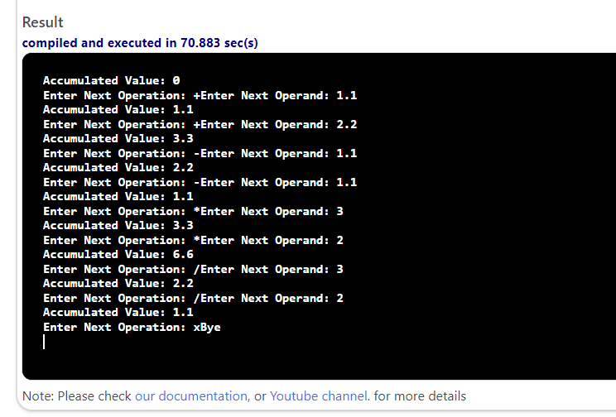

#include <iostream>

using namespace std;

void accumulate(double& acc, double opd, char op);

void accumulate(double& acc, double opd, char op)
{
switch (op)
{
case '+':
acc = acc + opd;
break;

case '-':
acc = acc - opd;
break;

case '*':
acc = acc * opd;
break;

case '/':
acc = acc / opd;
break;

}

}

int main()
{

double accumulator = 0;
char operation = '+';
double operand;
cout << "Accumulated Value: " << accumulator << endl;

while (operation == '+' || operation == '-' || operation == '*' || operation == '/')

{

cout << "Enter Next Operation: ";
cin >> operation;
if (operation == '+' || operation == '-' || operation == '*' || operation == '/')

{

cout << "Enter Next Operand: ";
cin >> operand;

accumulate(accumulator, operand, operation);
cout << "Accumulated Value: " << accumulator << endl;

}

}
cout << "Bye" << endl;
return 0;
}

